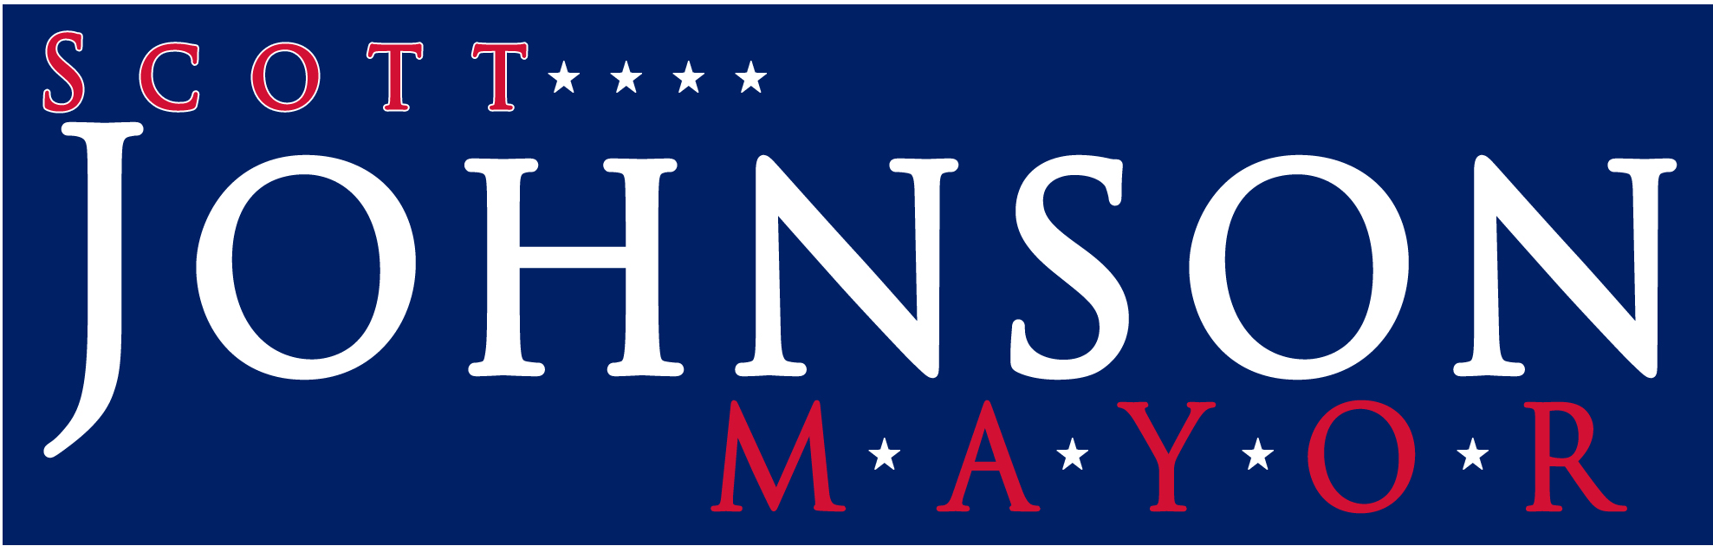
Please complete the following form and either:
Fax to 518-584-8599, or

Mail to PO Box 5075, Saratoga Springs, NY 12866
Contributions:  ______ $25  ______ $50  ______ $100  ______ $250 | I/we volunteer to:  ______ Canvass  ______ Host event  ______ Phone bank  ______ Stuff Mail  ______ Display lawn sign  ______ Put up lawn signs  ______ Sign maintenance | - Use name as supporter  _____________________  - Email address  _____________________

The following information is required to comply with New York Campaign Law:
Name Phone
Address
City, State, Zip
Occupation
Please make checks payable to “Johnson for Mayor” and send to:
PO Box 5075, Saratoga Springs, NY 12866
518-587-8888

